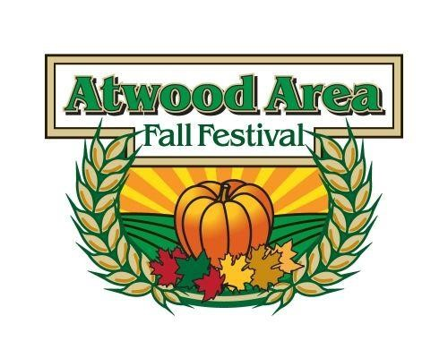
Control #: ________________
Payment: _________________
Confirmation Sent: __________
Atwood Area Fall Festival
Craft Application
October 4th, 5th and 6th 2024

Website: www.atwoodfallfest.org
Please print or type:

Name: ________________________________________________________

Address: _______________________________________________________

City: _________________________ State: ________ Zip: _________

Day Phone: ________________________ Evening Phone: ________________________

E-Mail: ____________________________ Website: _____________________________

Booth Space Requested: (please check the type of space being requested)
Campsite Exhibit Space (includes 2 nights camping) – Fee: $200/space - # of spaces: ____
o Camper Size: ________ ft.
10’ x 10’ booth space inside tent (1 table provided) – Fee: $155/space - # of spaces: ____
o Additional Tables available for $15.00/table.
o No E-Z Up or Pop-Up Tents allowed inside this space.

10’ x 10’ booth space outside – Fee: $140/space - # of spaces: ____
Total Fee Enclosed: $ ________
Payment must be submitted with application.
- Checks or money orders are to be made out to: Atwood Area Fall Festival
- o No postdated checks. o Full payment must be received at the time application is submitted.
  - No refunds after August 1st, 2024.
  - $25.00 Late fee after August 15, 2024 for all craft venders.
New vendors may be accepted at any time based on availability.

Please mail applications to: Atwood Area Fall Festival
PO Box 53
Sugarcreek, OH. 44681

- Please provide a list of items to be sold as well as pictures of each item to be sold.
  - Any applicant wishing to have their photographs returned must include a self-addressed stamped envelope with their application.
  - Only those items approved with this application may be sold at the festival. ___________________________________________________________

__________________________________________________________________

__________________________________________________________________

__________________________________________________________________

__________________________________________________________________

- Are all items listed above made by hand and not commercially manufactured?
Yes: _____ No: _____ (please check one)

Note: We encourage all vendors to decorate their booths.

Notice of acceptance or rejection will be sent within 30 days of receipt of application or at the Festival Committee’s earliest possible opportunity.
The applicant agrees to follow the Rules and Regulations of the Atwood Area Fall Festival Committee and the Muskingum Watershed Conservancy District (MWCD). Any violation may be cause for revocation of permit and/or immediate removal from the festival and park.
Upon acceptance, the exhibitor agrees to participate in the 2024 Atwood Area Fall Festival on October 4, 5 and 6 2024. The exhibitor agrees to abide by the Atwood Area Fall Festival Rules, and the Rules and Regulations of the Muskingum Watershed Conservancy District (MWCD), and acknowledges receipt of copies thereof. The exhibitor understands that this permit is not a lease, but permission to use certain conditional space at the Atwood Area Fall Festival. The exhibitor is not permitted to take additional space or move from assigned space unless permission is granted by the Atwood Area Fall Festival.
Exhibitor agrees, in connection with space reserved and participation in the Atwood Area Fall Festival, to indemnify and forever hold harmless the Atwood Area Fall Festival and the Muskingum Watershed Conservancy District (MWCD) from against all suits, claims, damages, or losses to persons and property sustained while upon Atwood Lake Park occasioned by any act, omission, neglect, or wrong doing of an exhibitor, his agents, or employees.
Please check this box if you wish to receive fliers to promote the next Atwood Area Fall Festival.
With this signature below I signify that I have read and will abide by the rules of The Atwood Area Fall Festival.
Signature of Applicant: __________________________________________ Date: __________________________

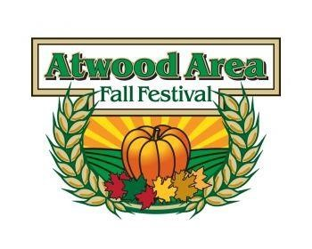
2024 CRAFT VENDOR’S RULES & REGULATIONS
of the

ATWOOD AREA FALL FESTIVAL Oct. 4-5-6
(KEEP FOR YOUR OWN RECORDS)

- Payments must be submitted with application. Returning vendors will be guaranteed a space if paid by December 1, 2024. New vendors may be accepted at any time based on availability.

- Each application must include prints & description of the items to be sold. Only items approved by the committee and on your application may be sold at the festival. Any applicant wishing to have their photographs returned must include a self-addressed stamped envelope with their application. Otherwise we will not return your photos.

- All items shown must be hand crafted by the exhibitor and be of high quality. Mass produced items are not acceptable. It is suggested that you display pictures showing your crafts being made or demonstrate making your crafts at your booth. This would prevent anyone suggesting that your crafts are not homemade.

- The Arts & Crafts Selection Committee reserves the right to ask exhibitors to remove items deemed unacceptable.

- Exhibitors must be set up by 10:00 a.m. Friday of the first day of the Atwood Area Fall Festival. Site assignments will be given upon confirmation. Table Exhibits may set up after 8 a.m. Thursday of the festival, and must be set by 10:00 a.m. Friday of the festival. No exhibits may be removed prior to 5:00 Sunday unless approved by an Arts & Crafts Committee Member. Exhibitors must be open from 10:00 a.m. to at least 9:00 p.m. Friday & Saturday and 10:00 a.m. to 5:00 p.m. Sunday of the Festival.

- Normal camping fees will be charged to the campsite venders by the Atwood Lake Park for overnight stays or by plugging into the electric box prior to the scheduled days of the festival. No fees will be charged if the units are set up with the electric unplugged and left unoccupied.

- Vehicles are to be parked in the area reserved for exhibitors. Vehicles will be permitted in the display area before 9:30 a.m. and after 9:00 p.m. Friday and Saturday, and before 9:30 a.m. and after 5:00 p.m. Sunday. If the exhibitor parking lot is full, you may have to park in general parking.

- Exhibitors are encouraged to demonstrate their craft when possible.

- No PETS at booths! No Pets allowed in festival area!

- No Private Golf Carts Permitted.

- Exhibitors will clean up and dispose of litter in booth spaces. All items must be removed by 9:00 am on the Monday immediately after the Festival. No trash burnt or left in fire ring!

- Trees must not be cut or damaged.

- No electric heaters, heat bulbs or household appliances permitted in tents due to power restrictions.

- No E-Z Up or Pop-Up Tents of any kind allowed under the large tents.

- There will be a $ 20.00 charge for ALL returned checks.

- Alcoholic beverages are prohibited on the premises.

- No Postdated Checks.

- Campsite Vendors - Only one wheeled camping unit and one storage unit per campsite. All campers, your display and storage vehicle must stay on the concrete pad provided.

- Exhibitors are to keep their items in the space provided. No items are permitted in the middle isle in the tents. Exhibitor is not permitted to take additional space or move from assigned space. No items or signs can be hung on the tent sides or roof at any time.

- Exhibitors are to abide by the Atwood Fall Festival Rules, and the Rules and Regulations of the Muskingum Watershed Conservancy District. Exhibitor understands that this permit is not a lease, but a permission to use certain conditional space at the Atwood Area Fall Festival.

- Exhibitor agrees, in connection with the space reserved and participation in the Atwood Fall Festival, to hereby agree to indemnify and forever hold harmless the Atwood Fall Festival and MWCD from and against all suits, claims, damages, or losses to persons and property sustained while upon Atwood Lake Park occasioned by any act, omission, neglect, or wrong doing of any exhibitor, his agents, or employees.

SETUP TIMES FOR 2024 ATWOOD AREA FALL FESTIVAL:

Campsite Vendors:

Sunday, Sept. 29, 2024 | 2:00 PM to 7:00 PM
Monday, Sept. 30, 2024 | 12:00 PM to 7:00 PM
Tuesday, Oct. 1, 2024 | 12:00 PM to 7:00 PM
Wednesday, Oct. 2, 2024 | 12:00 PM to 7:00 PM
Thursday, Oct. 3, 2024 | 8:00 AM to 8:00 PM
Friday, Oct. 4, 2024 | 7:00 AM to 9:30 AM

Tent Site Vendors: (Inside & Outside tents)

Thursday Oct. 1, 2024 |  | 8:00 AM to 8:00 PM
Friday Oct. 2, 2024 |  | 7:00 AM to 9:30 AM

Any other setup times are by appointment only! Please call 234-360-1644

If you show up at any other time you will be placed in a designated parking area until the setup time for that day, or will be held until the next day to be placed on your festival space.

NO EXCEPTIONS!

For more information, visit the Atwood Area Fall Festival Website at www.atwoodfallfest.org or call or e-mail Don or Cheryl 234-360-1644 and/or affcrafts@yahoo.com

